**W3D5 Solution**

***Question 1.***

***Question 2:***

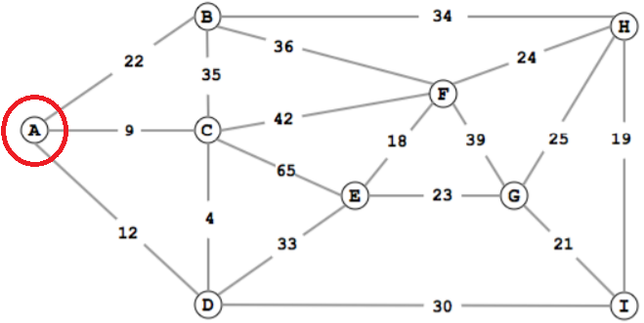

**A[A] = 0**

A[B] = A[A] + wt(A,B) = 0 + 22 = 22

A[C] = A[A] + wt(A,C) = 0 + 9 = 9

A[D] = A[A] + wt(A,D) = 0 + 12 = 12

**A[C] = 9**

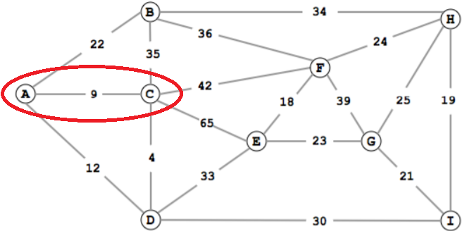

A[B] = A[A] + wt(A,B) = 0 + 22 = 22

A[D] = A[A] + wt(A,D) = 0 + 12 = 12

A[B] = A[C] + wt(C,B) = 9 + 35 = 44

A[F] = A[C] + wt(C,F) = 9 + 42 = 51

A[E] = A[C] + wt(C,E) = 9 + 65 = 74

A[D] = A[C] + wt(C,D) = 9 + 4 = 13

**A[D] = 12**

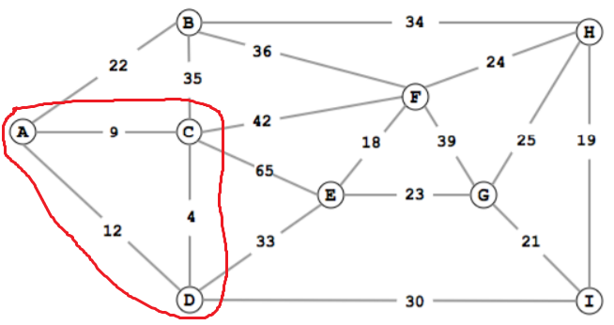

A[B] = A[A] + wt(A,B) = 0 + 22 = 22

A[B] = A[C] + wt(C,B) = 9 + 35 = 44

A[F] = A[C] + wt(C,F) = 9 + 42 = 51

A[E] = A[C] + wt(C,E) = 9 + 65 = 74

A[E] = A[D] + wt(D,E) = 12 + 33 = 45

A[I] = A[D] + wt(D,I) = 12 + 30 = 42

**A[B] = 22**

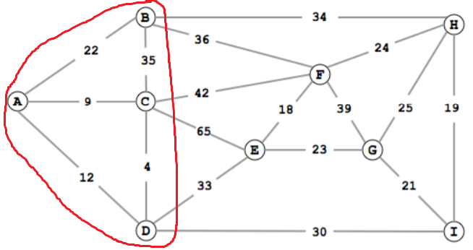

A[H] = A[B] + wt(B,H) = 22 + 34 = 56

A[F] = A[B] + wt(B,F) = 22 + 36 = 58

A[F] = A[C] + wt(C,F) = 9 + 42 = 51

A[E] = A[C] + wt(C,E) = 9 + 65 = 74

A[E] = A[D] + wt(D,E) = 12 + 33 = 45

A[I] = A[D] + wt(D,I) = 12 + 30 = 42

**A[I] = 42**

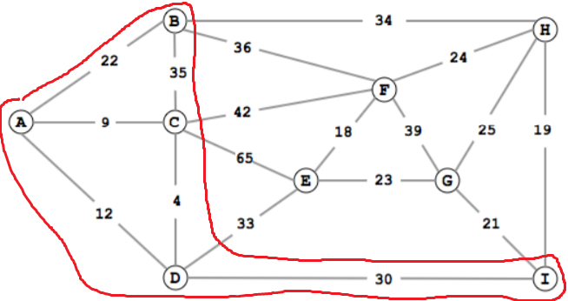

A[H] = A[B] + wt(B,H) = 22 + 34 = 56

A[F] = A[B] + wt(B,F) = 22 + 36 = 58

A[F] = A[C] + wt(C,F) = 9 + 42 = 51

A[E] = A[C] + wt(C,E) = 9 + 65 = 74

A[E] = A[D] + wt(D,E) = 12 + 33 = 45

A[H] = A[I] + wt(I,H) = 42 + 19 = 61

A[G] = A[I] + wt(I,G) = 42 + 21 = 63

**A[E] = 45**

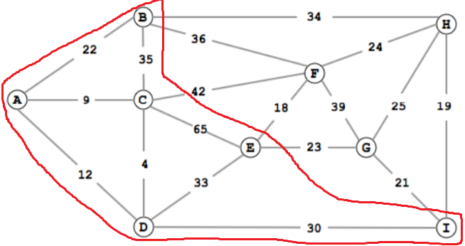

A[H] = A[B] + wt(B,H) = 22 + 34 = 56

A[F] = A[B] + wt(B,F) = 22 + 36 = 58

A[F] = A[C] + wt(C,F) = 9 + 42 = 51

A[F] = A[E] + wt(E,F) = 45 + 18 = 63

A[G] = A[E] + wt(E,G) = 45 + 23 = 68

A[H] = A[I] + wt(I,H) = 42 + 19 = 61

A[G] = A[I] + wt(I,G) = 42 + 21 = 63

**A[F] = 51**

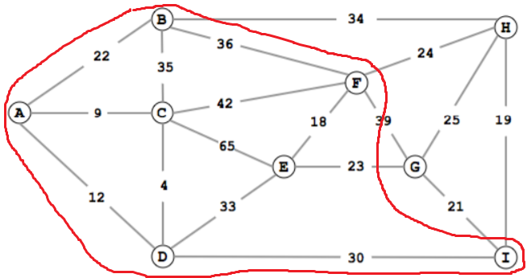

A[H] = A[B] + wt(B,H) = 22 + 34 = 56

A[H] = A[F] + wt(F,H) = 51 + 24 = 75

A[G] = A[F] + wt(F,G) = 51 + 39 = 90

A[G] = A[E] + wt(E,G) = 45 + 23 = 68

A[H] = A[I] + wt(I,H) = 42 + 19 = 61

A[G] = A[I] + wt(I,G) = 42 + 21 = 63

**A[H] = 56**

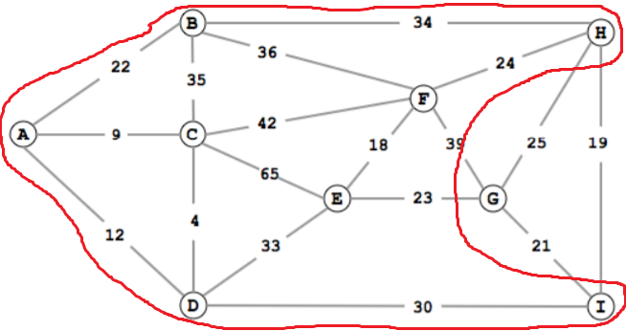

A[G] = A[H] + wt(H,G) = 56 + 25 = 81

A[G] = A[F] + wt(F,G) = 51 + 39 = 90

A[G] = A[E] + wt(E,G) = 45 + 23 = 68

A[G] = A[I] + wt(I,G) = 42 + 21 = 63

**A[G] = 63**

***Question 3:***

Avg case 🡺 O(nlogn)

Worst case 🡺 O(n2)

***Question 4 & 5:***

Material still not explained in class

***Question 6:***

***Question 7:***

**D[P] = 0**

D[Q] = D[P] + wt(P,Q) = 0 + 1 = 1

**D[Q] = 1**

D[R] = D[Q] + wt(Q,R) = 1 + 1 = 2

**D[R] = 2**

D[S] = D[Q] + wt(Q,S) = 1 + 4 = 5

D[S] = D[P] + wt(P,S) = 0 + 6 = 6

D[S] = D[R] + wt(R,S) = 2 + 2 = 4

**D[S] = 4**

D[T] = D[P] + wt(P,T) = 0 + 7 = 7

D[T] = D[S] + wt(S,T) = 4 + 3 = 7

**D[T] = 7**

D[U] = D[R] + wt(R,U) = 2 + 1 = 3

D[U] = D[S] + wt(S,U) = 4 + 2 = 6

D[U] = D[T] + wt(T,U) = 7 + 2 = 9

**D[U] = 3**

***Question 8:***

Avg case 🡺 O(nlogn)

Worst case 🡺 O(nlogn)

***Question 9:***

Yes

***Question 10:***

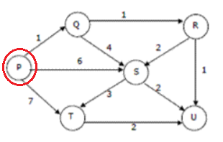

**A[P] = 0**

A[Q] = A[P] + wt(P,Q) = 0 + 1 = 1

A[S] = A[P] + wt(P,S) = 0 + 6 = 6

A[T] = A[P] + wt(P,T) = 0 + 7 = 7

**A[Q] = 1**

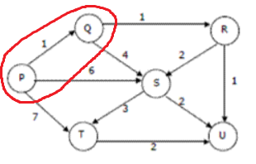

A[S] = A[Q] + wt(Q,S) = 1 + 4 = 5

A[S] = A[P] + wt(P,S) = 0 + 6 = 6

A[T] = A[P] + wt(P,T) = 0 + 7 = 7

A[R] = A[Q] + wt(Q,R) = 1 + 1 = 2

**A[R] = 2**

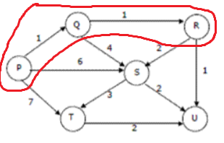

A[S] = A[Q] + wt(Q,S) = 1 + 4 = 5

A[S] = A[P] + wt(P,S) = 0 + 6 = 6

A[S] = A[R] + wt(R,S) = 2 + 2 = 4

A[T] = A[P] + wt(P,T) = 0 + 7 = 7

A[U] = A[R] + wt(R,U) = 2 + 1 = 3

**A[U] = 3**

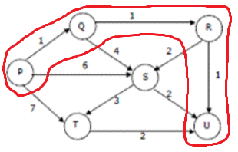

A[S] = A[Q] + wt(Q,S) = 1 + 4 = 5

A[S] = A[P] + wt(P,S) = 0 + 6 = 6

A[S] = A[R] + wt(R,S) = 2 + 2 = 4

A[T] = A[P] + wt(P,T) = 0 + 7 = 7

**A[S] = 4**

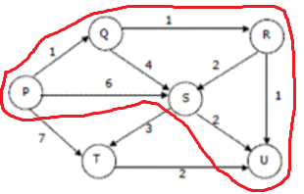

A[T] = A[S] + wt(S,T) = 4 + 3 = 7

A[T] = A[P] + wt(P,T) = 0 + 7 = 7

**A[T] = 7**